Challenge Template – User Guide

1. Unzip the template
2. Installing the archetype
   1. WINDOWS:
      1. Run the ‘install archetype.bat’ found in ‘Template’
   2. OTHER OS :
      1. Open the command prompt in the ‘Template’ folder
      2. Run the command: cd target/generated-sources/archetype
      3. Run the command: mvn install

Run the command: mvn install:install-file -Dfile=src/main/resources/archetype-resources/src/main/resources/MoCFramework-1.0-final.jar -DgroupId=MoC -DartifactId=MoCFramework -Dversion=1.0-final -Dpackaging=jar

1. Open netbeans and create a new project: maven -> project from archetype

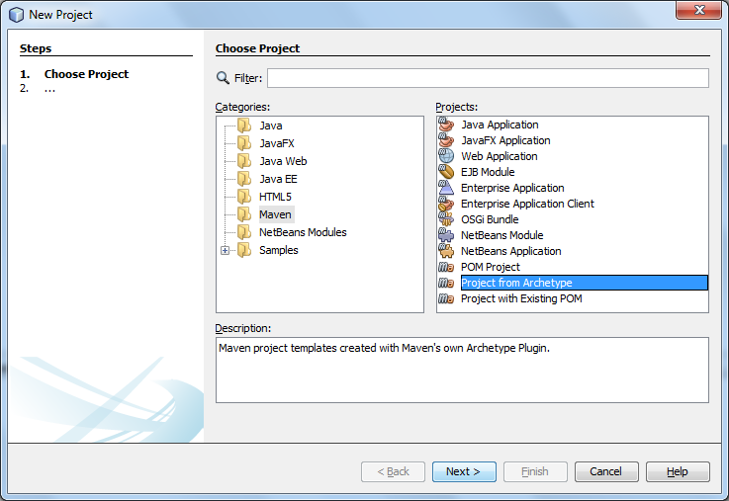

1. Select the MoCChallengeTemplate and click next

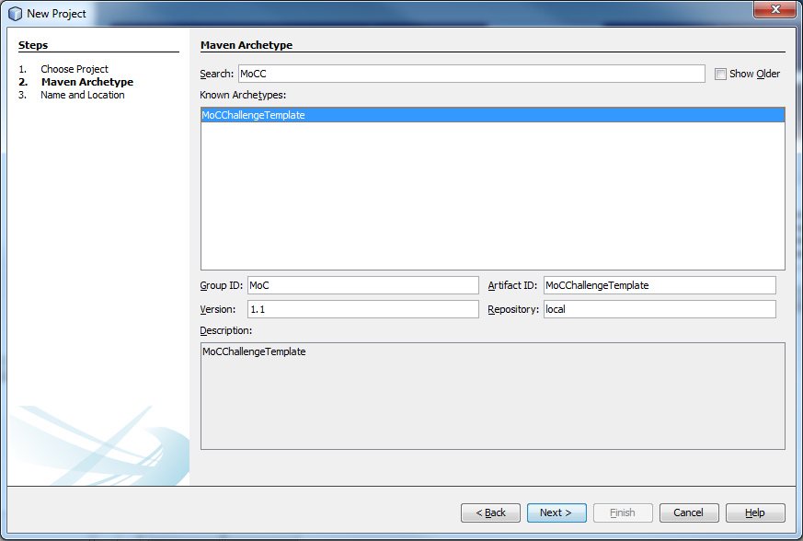

1. After the project is created, use the template to create and configure the challenge

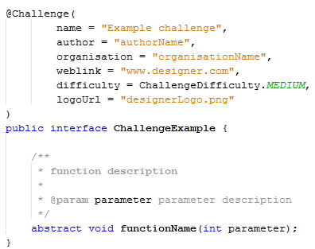

Rename the ChallengeExample interface, configure the information in the @Challenge annotation, and create the abstract functions needed for the challenge.

To create a java file that can be edited by the participants, put the annotation @Editable above the class. All java classes without this annotation can’t be edited by the participants.

There are three example tests in the challenge template: a UserTest, a SystemTest and an AmbivalentTest. A user test is a test that can be manually run by the participants while making the challenge. System tests can’t be run manually and will automatically be executed when turning in the challenge. To change the type of a test, change the “groups” property in the @Test annotation.

There are also three .txt files. *DescriptionParticipants.txt* contains the challenge description as read by the participants. *DescriptionPublic.txt* contains the challenge description as read by the public. *Hints.txt* contains a list with hints that will be given out during the challenge. Each hint starts on a new line in the file. During the competition, the hints will be released in the same order as the order they are written in in the file.

1. After you’re done, make sure to build the project: run -> build
2. A zip file of the challenge can be found in the target map of the project